English learner master plan

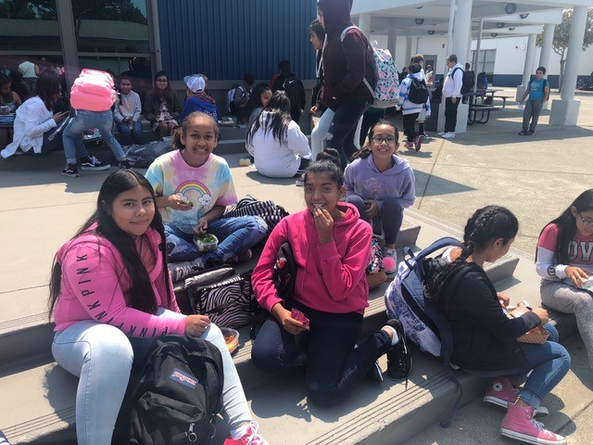

Revision Date: Spring 2019

DELAC approval date: May 8, 2019



Table of Contents

I - Involvement 1

I-EL-1 Parent Outreach and Involvement 1

I-EL-2 Translation of Information for Parents 1

I-EL-3 Private School Consultation and Participation 2

I-EL-04 English Learner Advisory Committee (ELAC) 3

Responsibilities ………………………………………………………………………………. 3

Composition Requirements ……………………………………………………………. 3

Elections …………………………………………………………………………………………. 3

Training ………………………………………………………………………………………….. 3

I-EL-05 District English Learner Advisory Committee (DELAC) 4

II – Governance and administration 6

II- EL-06 English Learner Identification and Assessment 6

II-EL-07: Parent/Guardian Notification 7

II-EL-08 Implementation, Monitoring, and Revision of District Plans 8

II-EL-09: EL Program Inclusion in Development of the SPSA 9

Initial identification, assessment, and Placement Flow Chart 10

Home Language Survey & EL Student Data Entry Procedures 11

III – FUNDING 13

III-EL-10 Inventory 13

III-EL-11: Supplement, Not Supplant, with Title III 14

III-EL-12 Time Accounting Requirements 14

IV – STANDARDS, ASSESSMENT AND ACCOUNTABILITY 15

IV-EL-13: Evaluation of English Learner Program Effectiveness 15

IV-EL-14: Reclassification 16

Assessment of English-Language Proficiency …………………………….. 16

Assessment of Basic Skills ………………………………………….………………. 16

Teacher Evaluation …………………………………………………….………………… 17

Parent Opinion …………………………………………………………………………….. 17

Procedure …………………………………………………………………………………….. 17

Follow-up for Reclassified Students …………………..……………………….. 18

V - STAFFING AND PROFESSIONAL GROWTH 20

V-EL-15 Teacher EL Authorization 20

V-EL-16: Professional Development Specific to English Learners 21

VI - OPPORTUNITY AND EQUAL EDUCATION ACCESS: 22

Waivers and Alternative Programs 22

VI-EL-17: Appropriate Student Placement 22

VI-EL-18: Parental Exception Waivers for Alternative Program 23

VII – TEACHING and LEARNING 25

VII-EL-19: English Language Development 25

Description of English Language Development (ELD) ……………….. 25

VII-EL-20: Access to the Core Subject Matter 26

EL program settings: Elementary 27

EL program settings: secondary 28

ELPAC Performance Level Descriptors 29

English language aquisition 30

# I - Involvement

Parents, staff, students, and community members participate in developing, implementing, and evaluating core and categorical programs.

## I-EL-1 Parent Outreach and Involvement

The district implements outreach to parents and guardians of English learners that includes the following:

1. Regular meetings are held (and notices sent out) in order to formulate and respond to parent recommendations.
2. Training activities to parents on how they can be involved and become active participants in assisting their children to:
   1. Attain English proficiency
   2. Achieve at high levels in the academic in core academic subjects
   3. Meet challenging state academic content and achievement standards expected of all students.

## I-EL-2 Translation of Information for Parents

The district provides parents and guardians with information on school and parent activities in a format and, to the extent practicable, in a language parents can understand.

When 15 percent or more of students enrolled in a public school speak a single primary language other than English, as determined by language census data from the preceding year, all notices, reports, statements, and records sent to parents of such students must be written in English and the primary language.

## I-EL-3 Private School Consultation and Participation

The district must contact private school officials in the district enrollment area to provide an opportunity to receive equitable Title III educational services and benefits to address the needs of eligible school students, their teachers, and their families.

1. On an annual basis, the district must consult with all non-profit private schools within its boundaries as to whether the private schools’ students and teachers will participate in the Title III, Part A, English Language Acquisition, Language Enhancement, and Academic Achievement Program as part of the ESEA programs available to them.
2. For participating private schools, the district must consult with appropriate private school officials during the design and development of the program concerning the following:
3. Identification of students’ needs;
4. Services or products which will be offered;
5. Service delivery options, including services through a contract with a third-party provider;
6. Assessment and improvement of services;
7. The size and scope of services and the proportion of funds allocated;
8. Program delivery options;
9. Reasons for not using a contractor preferred by private school officials;
10. The right to complain to state educational agency that the district did not engage in consultation that was meaningful and timely, or did not give due consideration to other views of the private school official;
11. Parents participate on an equitable basis in parental involvement services and activities; and,
12. The district assesses identified students annually for English language proficiency using a valid and reliable instrument.

## I-EL-04 English Learner Advisory Committee (ELAC)

All school sites where there are 21 or more English learners have a functioning English Learner Advisory Committee (ELAC).

### Responsibilities

The ELAC shall be responsible for the following tasks:

1. Advising the principal and staff in the development of a site plan for English learners and submitting the plan to the School Site Council for consideration of inclusion in the School Plan for Student Achievement.
2. Assisting in the development of the schoolwide needs assessment.
3. Ways to make parents aware of the importance of regular school attendance.
4. Each ELAC shall have the opportunity to elect at least one member to the District English Learner Advisory Committee (DELAC).

### Composition Requirements

Parents or guardians of English learners shall constitute at least the same percentage of the ELAC membership as their children represent of the student body.

### Elections

The parents or guardians of English Language learners shall elect the parent members of ELAC. Parents or guardians of English learners shall be provided the opportunity to vote in the election.

### Training

ELAC members shall receive training materials and training which will assist them in carrying out their required advisory responsibilities. Training shall be planned in full consultation with committee members, and funds from appropriate resources may be used to meet the costs of providing the training to include costs associated with the attendance of members at training sessions.

## I-EL-05 District English Learner Advisory Committee (DELAC)

If the district has more than 51 English learners, the district must operate functioning DELAC. In Cotati-Rohnert Park, the DELAC is operated as a subcommittee of the District Advisory Committee (DAC). At least 51 percent of the DAC members are parents (not employed by the district) of English learners.

The DELAC advises the school district governing board on all of the following tasks:

1. Development of a district master plan for educational programs and services for English learners that takes into consideration the school site master plan;
2. Conducting a district-wide needs assessment on a school-by-school basis (note: the district-wide needs assessments is conducted through the annual LCAP survey);
3. Establishment of district program, goals, and objectives for programs and services for English learners (note: the district records these programs, goals, and objectives in the LCAP);
4. Development of a plan to ensure compliance with any applicable teacher and instructional aide requirements;
5. Review and comment on the school district’s reclassification procedures;
6. Review and comment on the written parent notifications required to be sent to parents and guardians; and
7. If the DELAC acts as the English learner parent advisory committee under California Education Code Sections 52063(b)(1) and 52062(a)(2), the DELAC shall also review and comment on the development or annual update of the Local Control and Accountability Plan (LCAP).

The district must provide training materials and training, planned in full consultation with committee members, appropriate to assist members in carrying out their legal responsibilities. Funds from appropriate resources may be used to meet the costs of providing the training to include the costs associated with attendance of the members at training sessions.

Parents or guardians of English learners shall constitute the majority membership (51 percent or more) of the committee.

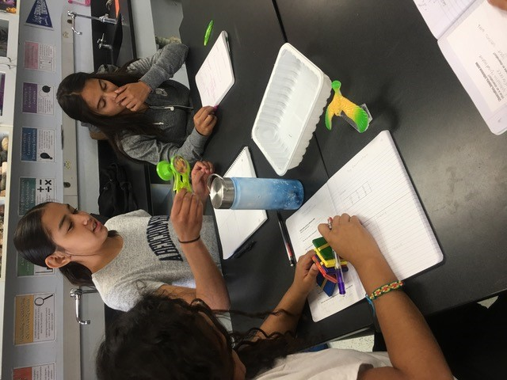

# II – Governance and administration

## II- EL-06 English Learner Identification and Assessment

The district has properly identified, assessed, and reported all students who have a primary language other than English. Please see the initial identification flow chart, following Section II.

1. A home language survey (HLS) must be completed at the time of initial enrollment to determine the student’s primary language.
2. Within thirty calendar days of initial enrollment, each student whose home language survey is other than English, as determined by the HLS, must be assessed for English proficiency by means of the current California English language proficiency assessment. The assessment conducted must follow all of the publisher’s instructions.
3. Each English learner must be annually assessed for English language development and academic progress.
4. All currently enrolled English learners must be assessed for English language proficiency by administering the current California English language proficiency assessment during the annual assessment window.
5. Each English language learner with disabilities must be assessed for English language development using accommodations, modifications, or alternate assessments for the current English language proficiency assessment if specified in the pupil’s IEP or 504 Plan.

## II-EL-07: Parent/Guardian Notification

Parents/guardians of English learners are notified of their child’s initial English language proficiency assessment results. Parents/guardians of initial fluent English- proficient students are notified of their child’s English language proficiency assessment results.

1. Parents/guardians of English learners must be notified annually of their child’s English language proficiency assessment results within 30 calendar days following receipt of results of testing from the test contractor.
2. For school districts receiving Title III funds, parents/guardians of English learners are informed annually, not later than 30 days after the beginning of the school year, of:
   1. Their child’s English proficiency level;
   2. How such level was assessed;
   3. The status of the child’s academic achievement;
   4. Their child’s language designation;
   5. Descriptions of program options and educational materials to be used in different options;
   6. Program placement;
   7. Exit criteria;
   8. English learners with a disability (on IEPs), how such a program will meet the objectives of the IEP; and,
   9. The expected rate of graduation from secondary school if funds under this part are used for children in secondary school.

## II-EL-08 Implementation, Monitoring, and Revision of District (LEA) Plans

Districts operating Title III programs must annually update, implement, and monitor the Title III Plan. The plan must contain the following minimum required components:

1. Description of programs and activities to be implemented;
2. Description of how funds will be used to meet all annual measurable objectives;
3. Description of how funds will be used to meet all annual measurable achievement objectives;
4. Description of how school sites will be held accountable for:
   1. Meeting annual measurable objectives;
   2. Making adequate yearly progress for English learners;
   3. Annually measuring the English proficiency of English learners;
5. Description of how school sites will promote parental and community participation in programs;
6. Description of how all English learner programs will be carried out to ensure that English learners are served;
7. Assurance that the EL program is based on scientifically-based research enabling English learners to meet challenging state academic content and student academic achievement standards; and,
8. Description of high-quality student academic assessments that the district and schools use:
   1. To determine the success of children in meeting state student academic achievement standards, and to provide information to teachers, parents, and students on the progress being made toward meeting the state student academic achievement standards; and,
   2. To assist in diagnosis and instruction in the classroom and to determine what revisions are needed so that English learners meet state student academic achievement standards.

## II-EL-09: EL Program Inclusion in Development of the SPSA

1. The EL Program must be included in the development of the School Plan for Student Achievement (SPSA).
2. The local governing board must review and approve the SPSA annually and whenever there are material changes to the plan.
3. The SPSA must be consistent with the LEA Plan and the LCAP.
4. Districts that distribute Title III funds or services directly to schools must ensure that the Title III programs operated at the schools are included in SPSAs, administered in accordance with the LEA Plan and LCAP, and adhere to all applicable statutes.

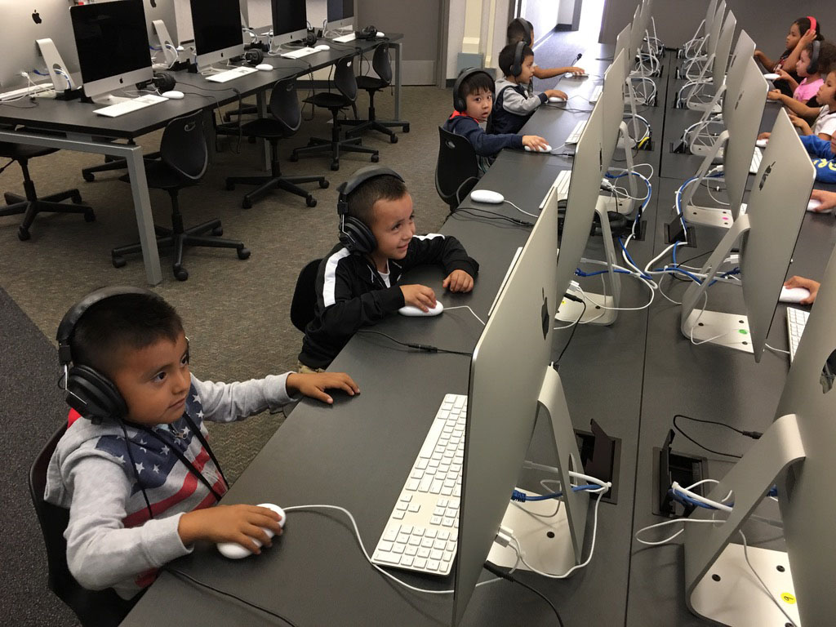

## Initial identification, assessment, and Placement Flow Chart

**New Enrollee**

(No record of primary language and English)

Parents complete

**“Home Language Survey”**

(HLS)

Language Classification is **EO**. Enroll student

in any

appropriate program.

**HLS** indicates

**English only**

on questions

1, 2, and 3

**HLS**

Language classification

is **EO**.

Assessment is at teacher discretion.

**HLS** questions 1-3 indicate English only, question 4 indicates a language other than English.

**HLS** indicates

language **other than English o**n questions

1, 2, and 3

**English Proficiency Assessment** (reading, writing speaking, and listening) completed within **30 days**.

Assessment is

**Initial Fluent English Proficient**

Language classification

is **IFEP**.

Enroll student

in any appropriate program.

Assessment is **Novice English Learner** or **Intermediate English Learner**

EL Students must receive:

* English Language Development (ELD) instruction daily
* Core curriculum instruction
* Additional and appropriate educational services
* SDAIE Instruction in core subjects from an appropriately credentialed teacher.

Language classification

is **EL**.

Enroll student in:

a) Structured English Immersion

b) English Mainstream OR

c) Alternative Program (with waiver)

## Home Language Survey & EL Student Data Entry Procedures

The parent of each student new to our district shall complete and sign a Home Language Survey (HLS) at the time of enrollment. If needed, the HLS is available in languages other than English. Copies are available in the school office. Please contact the Assistant Superintendent if additional copies are needed.

A completed HLS is a required record in each student’s cum folder.

1. From the enrollment card, enter the following information on the CALPADS screen: (HomeLang), (Birth City), (State), (Country), (US School Entry) & answers to HLS under Languages section: (First), (Primary), (at Home), and (by Adults).
2. If the survey is completed with English as a response to all four questions, the school office will file the HLS in the student’s cum file. The student’s English fluency is classified as English Only. Select **EO** for (Language Fluency).
3. If the survey is completed with English as a response to the first three questions and a language other than English to the fourth question, the student’s English fluency is classified Initially Fluent. Select **IFEP** for (LangFlu) and enter same date as (DistrictEntry) for (IFEP Date). A copy of the HLS is given to the EL Assistant. The original survey is filed in the student’s cum.
4. If the HLS is completed with a language other than English as a response to any of the first three questions, the student is referred for California English language fluency assessment by giving a copy of the HLS to the EL Assistant. Mark the student **TBD** under (LangFlu) pending the hand-scored results of the assessment. If results indicate the student is an English Learner, change the language fluency to **EL** for (LangFlu) AND complete the Program section fields: (Start Date) and (Program). If an English Learner has been granted a parental exception waiver, they are still coded **EL** under (LangFlu) and you must then complete the (English Language Development) field under Program information. The number of **EL** students should match the number of EL program participants at your school. [If the HLS is completed with English AND another language as a response to any of the first three questions, the student is referred for assessment by giving a copy of the HLS to the EL Assistant. The student’s English fluency is entered as English Learner -- Select **EL** for (LangFlu). If the student’s assessment scores indicate the student is in fact fluent, then change the classification to **IFEP**. If not, then leave as **EL** and complete the Program section fields: (Start Date), (Program)]
5. When a student attains sufficient English language skill, s/he will be reclassified. Change the language fluency (LangFlu) from **EL** to **RFEP** and enter the date of reclassification (Redes. Dt), the reclassification code of **RFEP** (Redes. Code) AND the end date (End Date) of the Services Received.
6. The cum file for each English Learner will indicate that s/he is an English Learner utilizing the “yellow folder”.
7. It is essential that students be entered into the student management system utilizing the correct language code, the correct language fluency code, and, for EL students, the correct program code and services received code.

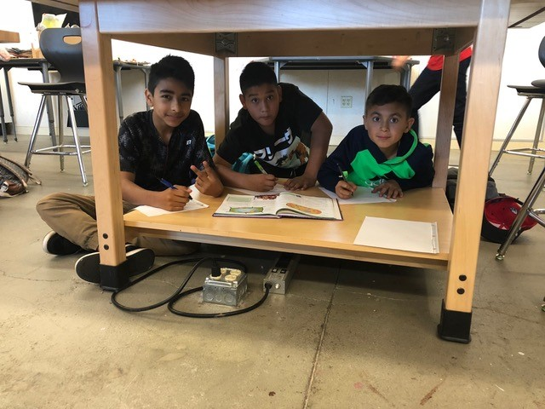

# III – FUNDING

Allocation and use of funds meet statutory requirements for allowable expenditures.

## III-EL-10 Inventory

The district maintains an inventory for each piece of equipment with an acquisition cost of $500 or more per unit that is purchased with Title III. The record must describe the acquisition:

1. Type
2. Model
3. Serial number
4. Funding source
5. Acquisition date
6. Cost
7. Location
8. Current condition
9. Transfer, replacement, or disposition of obsolete or unusable equipment.

The school district must conduct a physical check of the inventory of equipment within the past two years and has reconciled the results with inventory records.

## III-EL-11: Supplement, Not Supplant, with Title III

The district must use Title III funds only to supplement, not supplant, other federal, state, and local public funds. The use of Title III funds must meet the following requirements:

1. The district utilizes no less than 98 percent of the Title III apportionments on direct services to English learners and may not use more than two percent of such funds for the cost of administering the program.
2. Title III funds may not be used to meet state requirements for translations.

## III-EL-12 Time Accounting Requirements

The district properly assesses administrative charges for direct or indirect costs of Title III funds for salaries and wages in proportion to an allowable quantity and duties of each employee.   
  
Each employee paid in part from Title III and in part from other revenue, or an employee paid from multiple cost objectives, must complete a Personnel Activity Report (PAR) each pay period, or an approved sampling method must be used.

Employees funded solely under Title III must complete a semiannual certification of such employment.

# IV – STANDARDS, ASSESSMENT AND ACCOUNTABILITY

Categorical programs meet state standards are based on the assessed needs of program participants, and achieve the intended outcomes of the categorical program

## IV-EL-13: Evaluation of English Learner Program Effectiveness

An annual program evaluation shall be conducted by the district and shall determine:

1. Necessary improvements to programs and activities for which Title III funds have been used;
2. The effectiveness of programs and activities in assisting EL students to attain proficiency and to meet achievement and content standards;
3. Whether or not to continue the program or activities;
4. The degree to which, within a reasonable amount of time:
   1. English learners are achieving English language proficiency comparable to that of average native speakers of English in the district; and,
   2. Academic results indicating that English learners are achieving and sustaining parity of academic achievement with students who entered the district’s school system already proficient in English.

Evaluations will be documented and incorporated in the LCAP.

## IV-EL-14: Reclassification

The district reclassifies students from English learner to proficient in English by using a process and criteria that include, but are not limited to:

1. Assessment of language proficiency using an objective assessment instrument, including, but not limited to, the English language development test that is developed or acquired pursuant to Section 60810.
2. Teacher evaluation, including, but not limited to, a review of the pupil's curriculum mastery.
3. Parental opinion and consultation.
4. Comparison of the performance of the pupil in basic skills against an empirically established range of performance in basic skills based upon the performance of English proficient pupils of the same age, that demonstrates whether the pupil is sufficiently proficient in English to participate effectively in a curriculum designed for pupils of the same age whose native language is English.

### Assessment of English-Language Proficiency

At the opening of the testing window each school year, staff at each school administers a state adopted test of English language proficiency to all returning and newly enrolled English learners who have not been reclassified to Fully English Proficient (RFEP).

### Assessment of Basic Skills

The basic skills of English learners are assessed against an empirically established range in performance in basic skills based upon the performance of English proficient students of the same age that demonstrate whether the student is sufficiently proficient in English to participate effectively in a curriculum designed for pupils of the same age whose native language is English.

1. For students in grades K-8, EasyCBM screening tests are used to determine a comparative level of basic literacy skills. In grades 9-12, intervention program screening tests are used to determine comparative levels of basic literacy skills.
2. Other objective data on the student’s academic performance in English language arts may be considered. These data should demonstrate that the student’s skill in this area is comparable to those of native English-speaking peers.

### Teacher Evaluation

Teachers complete a narrative evaluation documenting that student’s English language proficiency is comparable to that of native English speakers.

### Parent Opinion

Parents/guardians are consulted and their opinions solicited in the reclassification process.

### Procedure

1. The Reclassification review process begins when either (a) or (b) occurs:
   1. During annual assessment using the current California English language proficiency assessment (ELPAC), a student scores at Level 4 in all four skill areas (listening, speaking, reading, and writing).
   2. Eligibility for Reclassification is recommended by the teacher, EL assistant, parent(s), administrator, and designated EL Coordinator/Teacher (and at the secondary level, the counselor).
2. Each site will designate a certificated staff member to review the reclassification data with appropriate staff and the parent to validate the reclassification determination. The designated staff member completes the reclassification form, obtains the teacher signature, and request the parent signature. Parent may approve in writing or give verbal permission.
3. The district EL Reclassification Data form is used to document the process.
4. When the student is reclassified as RFEP, the site’s designated staff makes appropriate changes to the English Language page in the student information system (including program date added, program start and program end), the Yellow EL Folder.

### Follow-up for Reclassified Students

The district monitors the academic progress of each reclassified student for a minimum of four years after reclassification to ensure correct classification, placement, and additional academic support if needed.

1. Individual Student Level:
   1. Monitoring will occur twice a year when relevant performance data is available and will be conducted by the site EL coordinator, EL assistant, or EL Records Clerk. Results will be documented in the student’s English Learner file using the RFEP Follow-up Monitoring Form.
   2. At any time after designation to RFEP, the student’s RFEP status may be re-evaluated at the recommendation of teacher, parent, or administrator by calling for a Student Study Team (SST) meeting. Possible outcomes of the SST may include recommendations for academic, social, emotional, health or community support and/or referral to Alternative Programs. The effectiveness of the EL program is monitored by following the rates of reclassification and success of reclassified students during the follow-up period.
2. School/District Level:
   1. Data are collected and reviewed annually to ensure that former EL students have not been left with any substantive academic deficits. This review will include monitoring of the annual state academic test results, benchmark examinations, and other local progress monitoring assessments.
   2. The pupil’s permanent record contains documentation of the following:

* Language and academic performance assessments
* Participants in the reclassification process
* Decision regarding reclassification

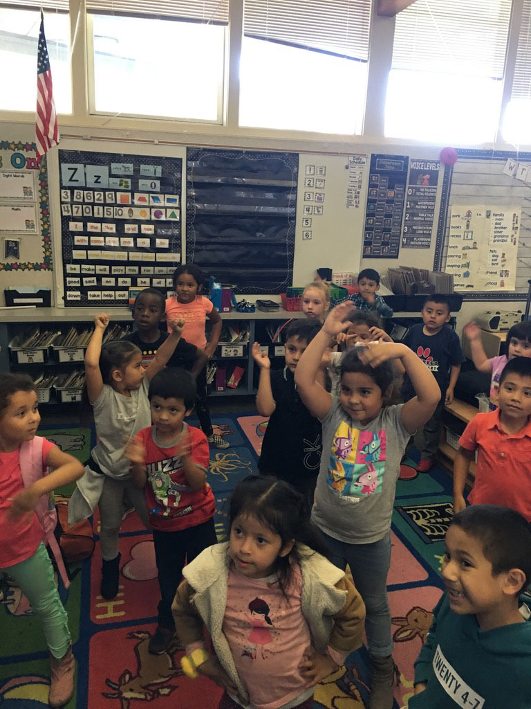

# V - STAFFING AND PROFESSIONAL GROWTH

Staff members are recruited, trained, assigned, and assisted to ensure the effectiveness of the program.

## V-EL-15 Teacher EL Authorization

Teachers assigned to provide English language development and instruction in subject matter courses for English learners are appropriately authorized.

When teacher recruitment is necessary, only candidates who hold a CLAD credential or the equivalent are considered. In the event of a local shortage of qualified teachers, the District will adopt and implement measures to remedy the shortage. (V-EL 7.1)

## V-EL-16: Professional Development Specific to English Learners

The district provides professional development specific to the implementation of programs for English learners for classroom teachers, principals, administrators, and other school or community-based personnel that is:

1. Designed to improve the instruction and assessment of English learners;
2. Designed to enhance the teacher’s ability to understand and use curricula, assessment measures, and instructional strategies for English learners;
3. Based on research demonstrating the effectiveness of professional development in increasing students’ English proficiency or the teacher’s subject matter knowledge, teaching knowledge, and teaching skills.
4. Of sufficient intensity and duration (which shall not include activities such as one-day or short-term workshops) to have a positive and lasting impact in the classroom.

# VI - OPPORTUNITY AND EQUAL EDUCATION ACCESS:

# Waivers and Alternative Programs

## VI-EL-17: Appropriate Student Placement

All students are placed in English language classrooms unless a parental exception waiver has been granted for an alternative program in which some or all of the instruction is delivered in the student’s primary language. Based on district criteria of reasonable fluency, English learners must be placed in one of the following programs:

1. Structured English Immersion (SEI), in which the language acquisition process, curriculum, and instruction are designed for students who are learning the language;
2. English Language Mainstream (ELM), in which English learners who do not meet the district criteria for placement in SEI are placed upon parent/guardian request.
3. Alternative Program: For students with an approved parental exception waiver, an alternative program in which some or most of the instruction is delivered in the student’s primary language, unless there is an IEP in which the IEP team determined the need for primary language instruction.

## VI-EL-18: Parental Exception Waivers for Alternative Program

Parents and guardians of English learners are notified annually of the opportunity to apply for a parental exception waiver for their children to participate in an alternative program in which some or all of the instruction is delivered in the student’s primary language.

The district procedures for granting parental exception waivers include the following:

1. Parents and guardians are provided, on enrollment and annually, full written, and upon request, spoken descriptions of the Structured English Immersion (SEI) program, the English Language Mainstream (ELM) program, alternative programs, and all educational opportunities available to the student. The descriptions of these programs include the educational materials used in the different options.
2. Parents and guardians are informed that a student must be placed for not less than thirty calendar days in an English language classroom the first year of enrollment in a California school.
3. Parents and guardians are informed of any recommendation by the school principal and educational staff for an alternative program and given their right to refuse the recommendation.
4. Parental exception waivers are acted on within twenty instructional days of submission to the principal. However, waivers submitted under EC 311(c) must be acted upon either not later than ten calendar days after the expiration of the thirty-day English language classroom placement or within twenty instructional days of submission of the waiver, whichever is later.

Parental exception waivers shall be granted unless the school principal and educational staff determine that an alternative program offered at the school would not be better suited for the overall educational development of the student.

If a waiver is denied, parents and guardians must be informed in writing of the reason(s) for denial and advised that they may appeal the decision of the local board of education if such an appeal is authorized by the local board of education, or to the court.

Each school in which twenty or more students of a given grade level receive a waiver shall be required to offer such a class; otherwise they must allow the students to transfer to a public school in which such a class is offered.

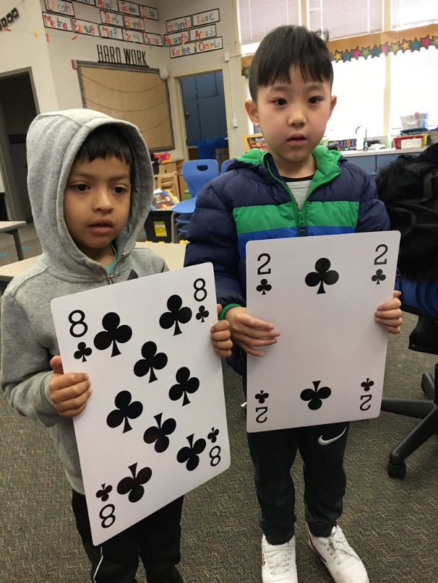

# VII – TEACHING and LEARNING

Participants receive core and categorical program services that meet their assessed needs.

## VII-EL-19: English Language Development

As part of the core program provided through general funds, each English learner must receive a program of instruction in English language development (ELD) in order to develop proficiency in English as rapidly and effectively as possible.

Each English learner must receive ELD through both designated ELD and ELD instruction integrated into content courses.

### Description of English Language Development (ELD)

The English Language Development component of all instructional program models is research- based and recognizes that the acquisition of English as a second language is a developmental process. Research recognizes that no two students will develop proficiency in English at the same rate. In most cases, Basic Interpersonal Communication Skills (BICS) appear long before Cognitive Academic Language Proficiency (CALP), and time and opportunity must be allowed for this development to occur. Indeed, it may take five to seven years to achieve academic English proficiency comparable to that of native English-speaking peers. Each English learner will develop at his/her own pace, depending on a multitude of environmental, personality, learning and educational factors.

ELD is a component of all instructional programs designed to serve the needs of English Learners. Further, ELD is a specific curriculum based on the California English Language Development Standards that addresses the teaching of the English language according to the level of English proficiency of each student. The purpose of ELD is to teach second language learners to communicate (listen and speak) with high levels of understanding in English. Additionally, ELD provides the foundation for literacy (reading and writing) as well as a pathway to the California English Language Arts Standards. The shared goal is to assist students in developing skills so that they may achieve cognitive academic proficiency in English. ELD can occur in a variety of instructional settings.

English Language Development must be a part of the daily program for every English Learner student, as required by law. ELD must be a planned, specific, explicit component of the total education of the EL student. There is no maximum amount of time for a student’s ELD. However, it is mandatory that each EL student receive these minimum periods of ELD per day: 30-40 minutes Kindergarten-Grade 5 and at least one period per day in middle and high school.

## VII-EL-20: Access to the Core Subject Matter

Academic instruction for English learners is designed and implemented to ensure that English learners meet the district’s content and performance standards for their respective grade levels within a reasonable amount of time.

The district assists English learners to achieve high levels in the core academic subjects to ensure that they meet the same challenging state content and achievement goals all children are expected to meet.

The district monitors students’ academic progress and responds to assist students in overcoming any academic deficits incurred while acquiring English. Actions to overcome academic deficits are taken before the deficits become significant.

## EL program settings: Elementary

|  |  |  |
| --- | --- | --- |
| Type of Setting | Eligible Students | Curriculum Components |
| Structured English  Immersion | **English Learners**   * State Assessment Proficiency Level (Standard not met, Standard nearly met*)   *In some cases | * **Explicit ELD Daily**: 30-40 minutes; district-adopted textbooks and supplementary materials * **Access to core:** differentiated instruction in reading, writing, mathematics, social studies and science with Specially Designed Academic Instruction in English (SDAIE) strategies and materials * **Primary Language support (L1):** motivate, clarify, direct, support, explain, minimal, as needed |
| English Language  Mainstream | **English Learners**   * State Assessment Proficiency Level (Standard nearly Met*, Standard Met, Standard Exceeded)   *In some cases | * **Explicit ELD Daily:** 30-40 minutes; district-adopted textbooks and supplementary materials * **Access to core:** differentiated instruction in reading, writing, mathematics, social studies and science with (SDAIE) strategies and materials * **Primary Language Support (L1):** minimal, as needed |

## EL program settings: secondary

|  |  |  |
| --- | --- | --- |
| Type of Setting | Eligible Students | Curriculum Components |
| Structured English  Immersion | **English Learners**   * State Assessment Proficiency Level (Standard not met, Standard nearly met*)   *In some cases | * **Explicit ELD Daily**: 1-2 periods; district-adopted textbooks and supplementary materials * **Access to core**: differentiated instruction in mathematics, social studies and science with Specially Designed Academic Instruction in English (SDAIE) strategies and materials * **Physical Education and Electives:** mixed group of EL, RFEP, IFEP, and EO students * **Primary Language support (L1):** motivate, clarify, direct, support, explain, minimal, as needed |
| English Language  Mainstream | **English Learners**   * State Assessment Proficiency Level (Standard nearly Met*, Standard Met, Standard Exceeded)   *In some cases | * **Explicit ELD Daily**: 1 period; district-adopted textbooks and supplementary materials * **Access to core**: differentiated instruction in English, mathematics, social studies and science with (SDAIE) strategies and materials * **Primary Language Support (L1):** minimal, as needed |

## ELPAC Performance Level Descriptors

**ELPAC Performance Level Descriptors & ELD Standards Proficiency Levels (Version 1)**

|  |  |  |  |  |  |  |
| --- | --- | --- | --- | --- | --- | --- |
| ELPAC | Level 1 | Level 2 | | Level 3 | | Level 4 |
| ELD Standards | Emerging | Low Expanding | Mid Expanding | Upper Expanding | Lower Bridging | Upper Bridging |

**ELPAC Performance Levels – Relation to ELD Standards**

|  |  |  |  |  |  |
| --- | --- | --- | --- | --- | --- |
| ELPAC Levels | Level 1 | Level 2 | Level 3 | | Level 4 |
| ELD Standards Proficiency Levels | Emerging – requires substantial linguistic support | Expanding – requires moderate linguistic support | | Bridging – requires light linguistic support | |

**ELPAC Performance Levels – Descriptors**

|  |  |
| --- | --- |
| ELPAC Levels | What Students Can Typically Do at Each Level |
| Level 1 Minimally Developed | Students at this level are at a beginning stage of developing English skills.  - They usually need substantial help using English to learn new things at school  and to interact in social situations.  - They may know some English words and phrases. |
| Level 2 Somewhat Developed | Students at this level have somewhat developed English skills.  - They usually need help using English to learn new things at school and to  interact in social situations.  - They can often use English for simple communication. |
| Level 3 Moderately Developed | Students at this level have moderately developed English skills.  - They can sometimes use English to learn new things in school and to interact in  social situations.  - They may need help using English to communicate on less-familiar school  topics and in less-familiar social situations. |
| Level 4 Well Developed | Students at this level have well developed English skills.  - They can usually use English to learn new things in school and to interact in  social situations.  - They may occassionally need help using English. |

## English language aquisition

**Expected Rate of English Language Acquisition**

|  |  |  |  |  |  |
| --- | --- | --- | --- | --- | --- |
| **Assessed ELD Level** | **Minimally**  **Developed**  **Level 1** | **Somewhat**  **Developed**  **Level 2** | **Moderately**  **Developed**  **Level 3** | **Well**  **Developed**  **Level 4** | **1st Year After Redesignation** |
| **Timeline based on Student’s**  **ELD**  **Level at entry into District** | **1st Year** | **2nd Year** | **3rd Year** | **4th Year** | **5th Year** |
|  | **1st Year** | **2nd Year** | **3rd Year** | **4th Year** |
|  | **1st Year** | **2nd Year** | **3th Year** |
|  | **1st Year** | **2rd Year** |
|  | **1nd Year** |
| **ELD Standards Proficiency Level** | **Emerging** | **Emerging/**  **Expanding** | **Expanding/**  **Bridging** | **Bridging** | **English Language Arts Standards** |
| **State English Language Arts**  **Standards Test** | **Standard**  **Not Met** | **Standard**  **Nearly**  **Met** | **Standard**  **Met** | **Standard**  **Exceeded** |